/\*IPBC MO.Proj R2SP5 Story 7 Lab 8.5.19\*/

4. Complete R2:SP5: Story 7 – Create the Loans To Date part of the Dashboard. Explain the entire process with explanations &amp; screenshots. While everything doesn’t need to be captured,

milestones such as completed queries and reports should be documented.

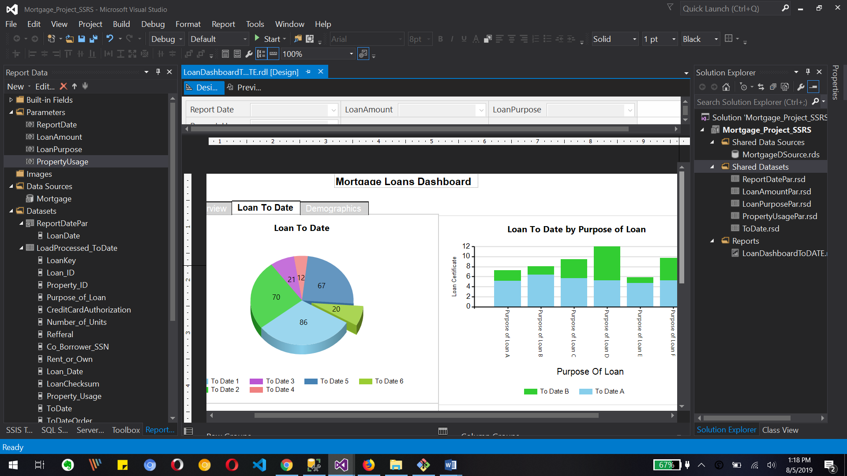

This is the SSRS image with shows different parameters data set data source and share data set for lawn dashboard. Also we can see pie chart and bar chart for lawn today despot

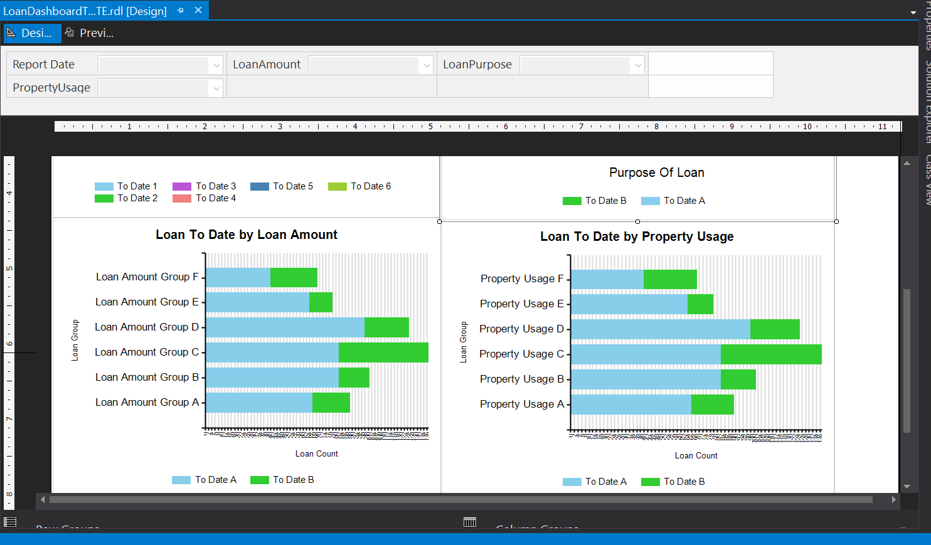

This image shows Loan to date by loan amount and by property usage in bar charts.

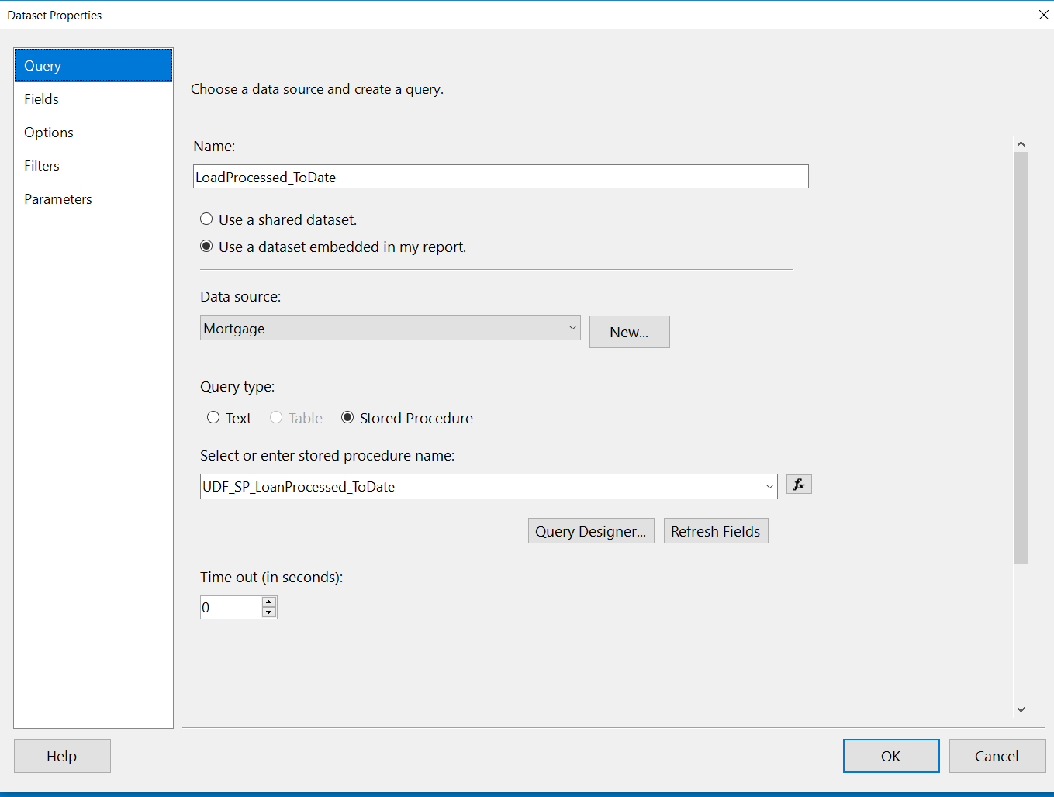

This is main data set property of SSRS package where I have selected stored procedure Turon which is stored in SQL Server database

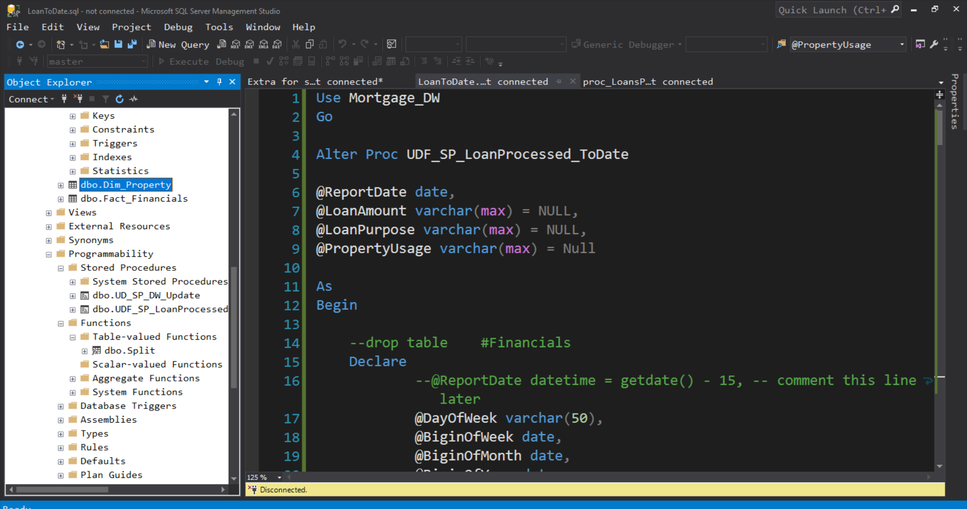

This is user-defined loan processed today stored procedure where I have four different parameters

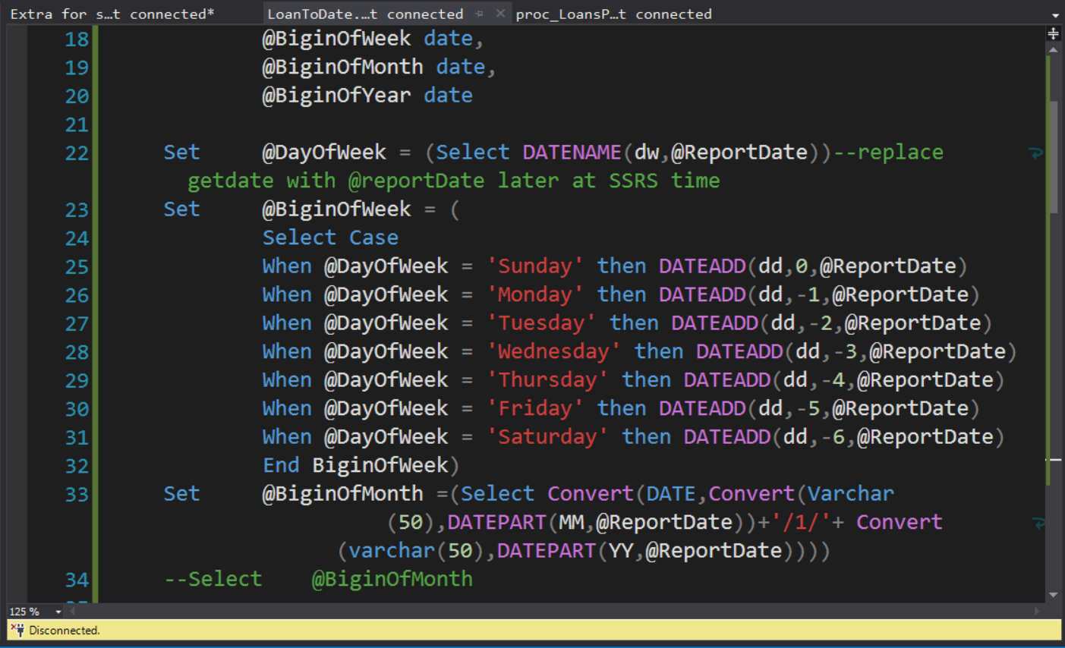

To find begin of week, begin of month and begin of your I used dateadd and get date functions

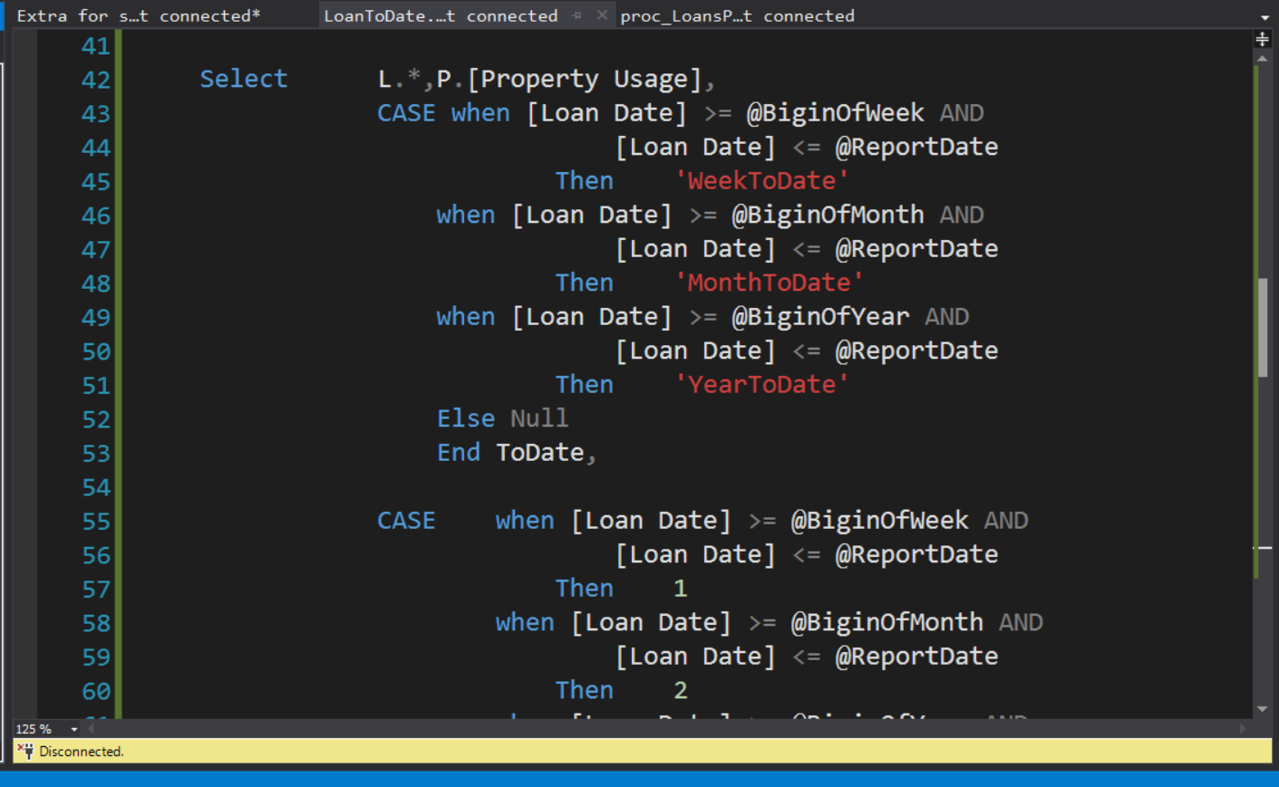

We need to use case statement to get WeekToDate, month-to-date and year-to-date data for loan date into temporary table

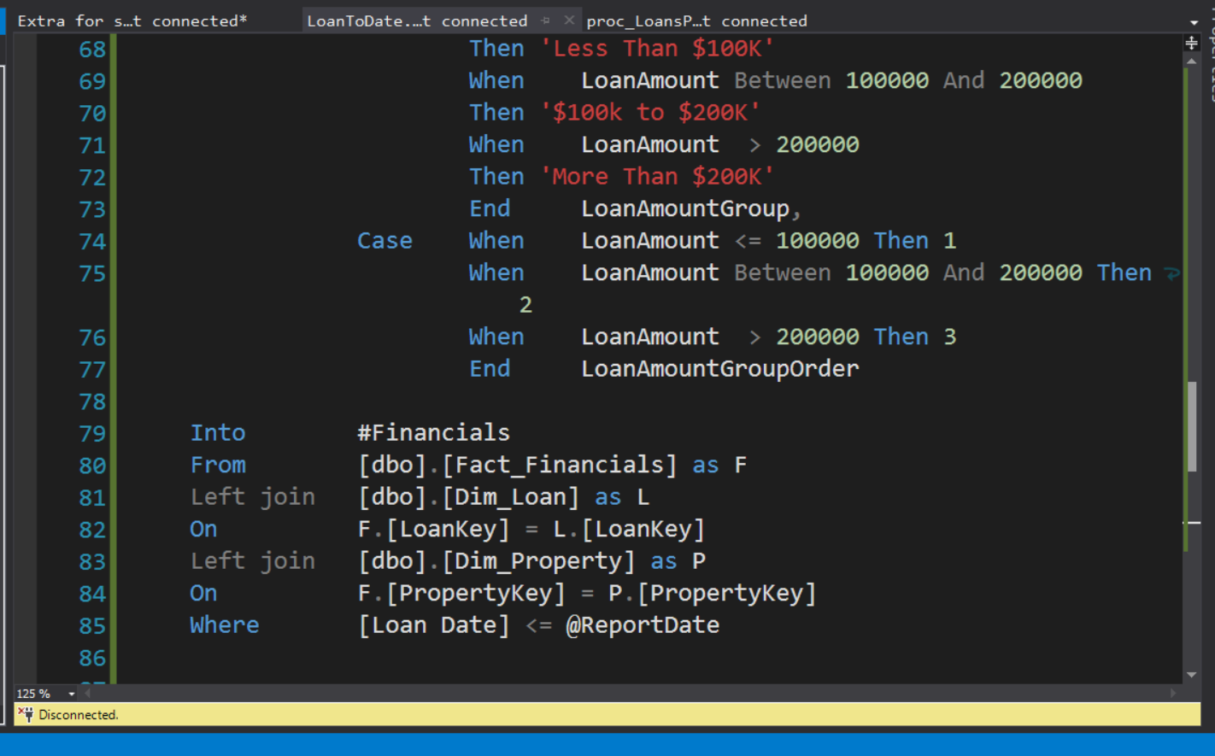

Also be divided loan amount in three different categories as Below 100k, between 100K to 200k, more than 200k for that we use case statement to get that data into temporary table.

We join fact financial, dimension loan and dimension property so far to get all those data

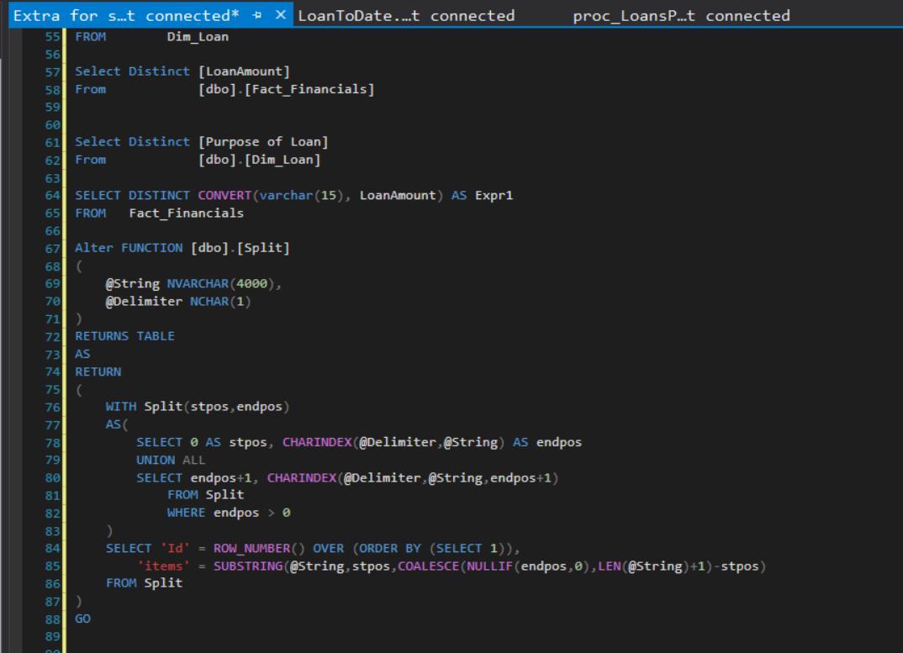

I have created split function to splitter coming data home parameter of stored procedure to divide the data by comma

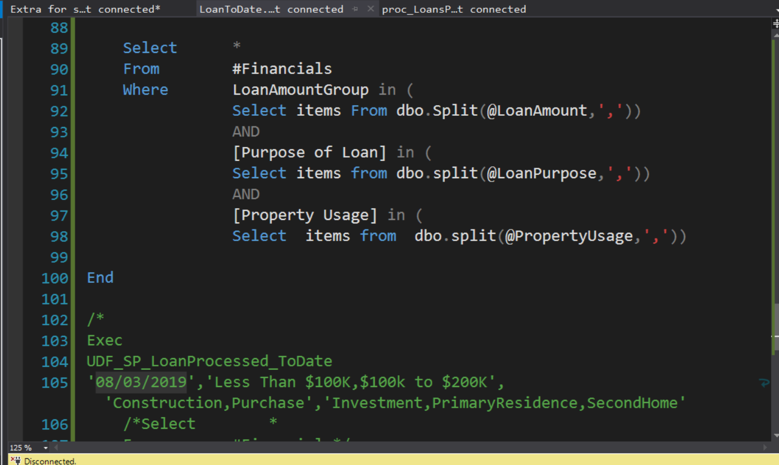We use split function to separate parameters string data into separate so we use them one by one.

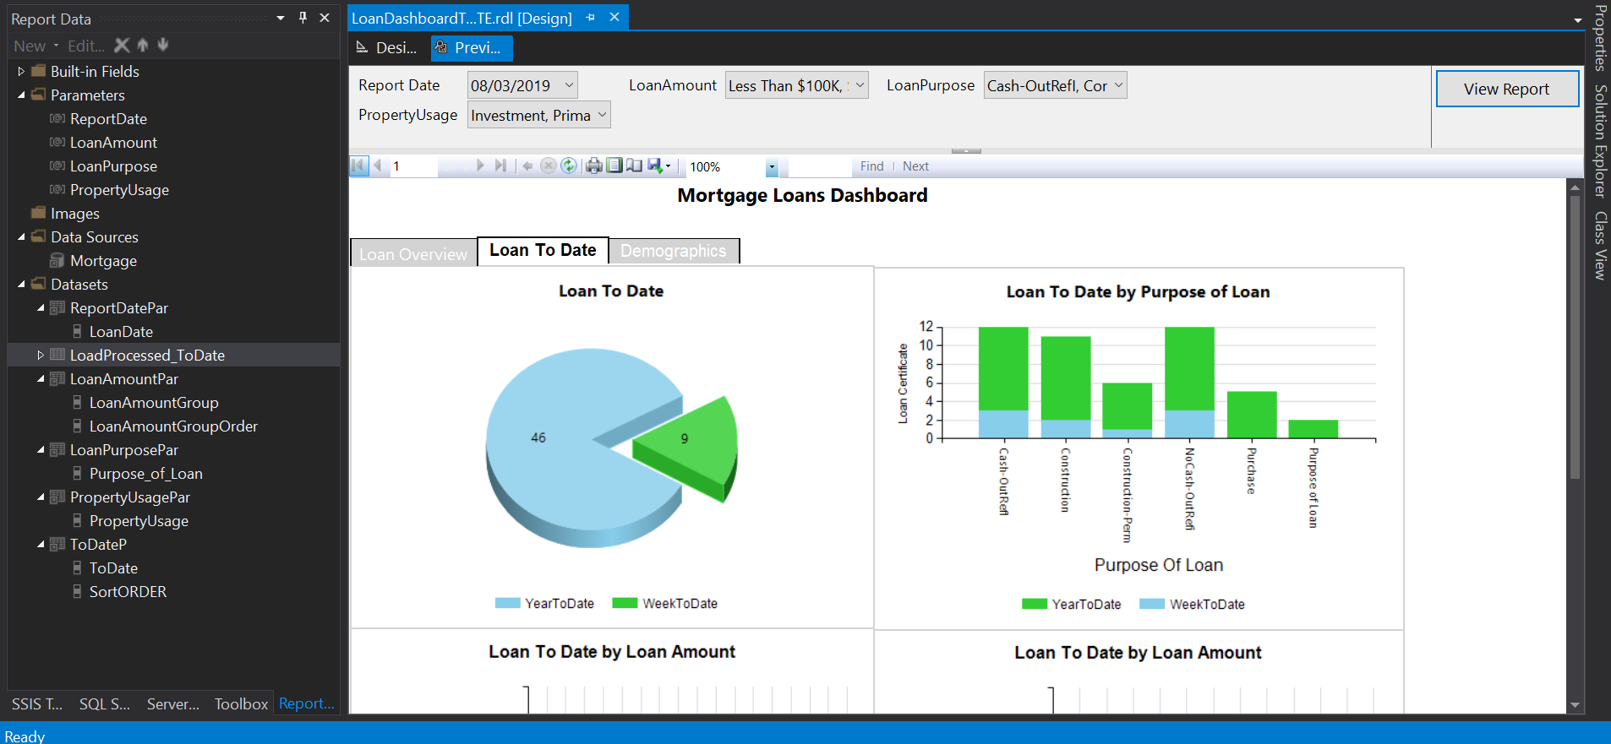

This is the preview of my report where it says loan to date and loantodate by purpose of loan as per values from parameters

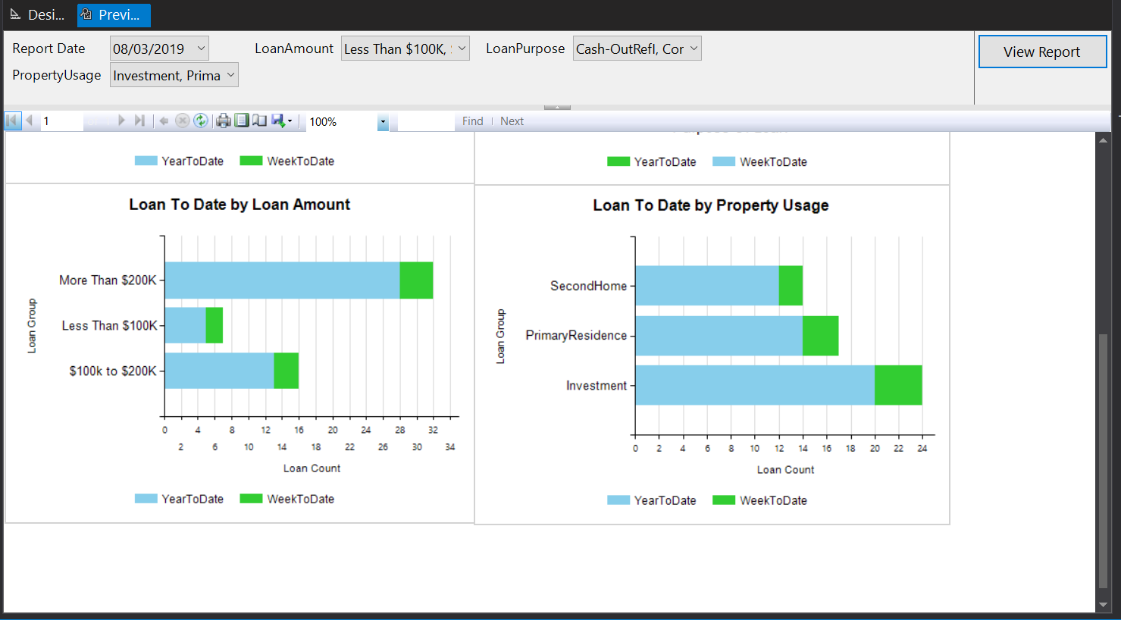

It's shows loantodate by loan amount and loan to date my loan property usage wit the help of parameters

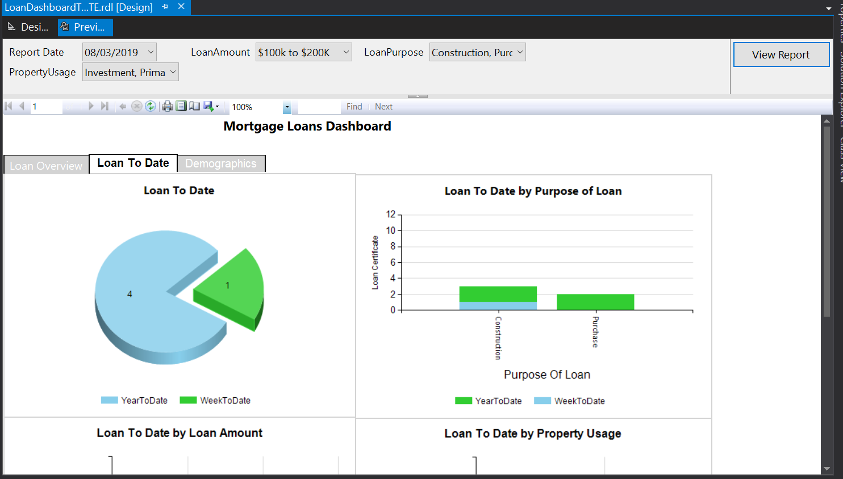

Now we change loan amount parameter to $100k to $200k and loan purpose parameter to see the view of report, So we can see the changes in report display.



The same way as per parameters value selection we can see the change in loan to date by loan amount and loan to date by loan property usage

What to Submit:

1. 1. SQL BI Interview Questions: SSRS – Name 5 functions you have used in SSRS

<https://app.colaberry.com/app/ipbc/videos?user=31221&category=44>

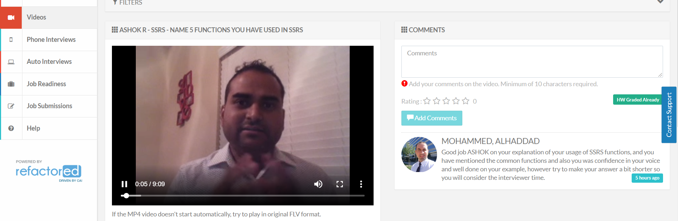

1. 2. SQL BI Interview Questions: SSRS – If you do not have a business analyst on your team, how do you get the requirements

<https://app.colaberry.com/app/ipbc/videos?user=31221&category=42>

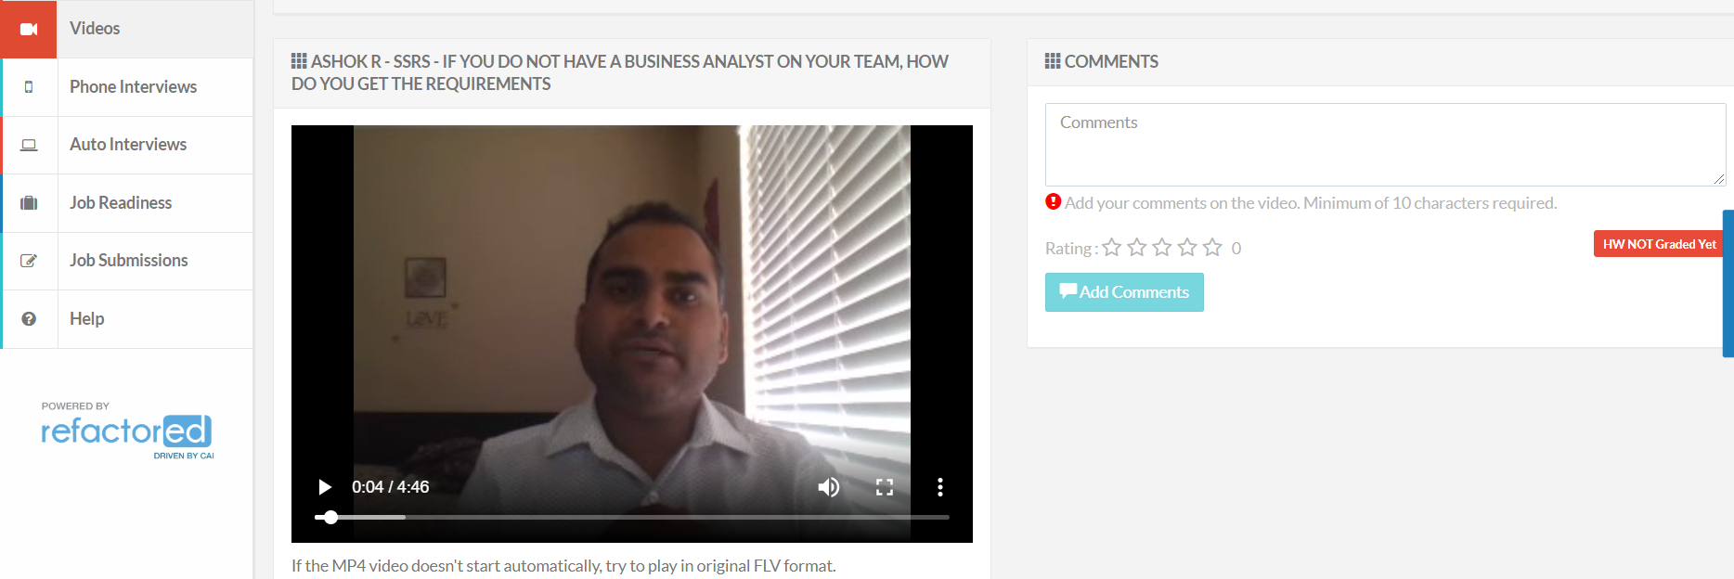

1. Watch, Comment &amp; take screenshots of your comments from 3 other videos on the same topic (per question). Comments must be 20+ characters. Leave comments based on presentation, delivery and/or technical details. Your critiques will help you be more conscious of your own videos. (3 comment screenshots per Video Question)

* Name 5 functions you have used in SSRS

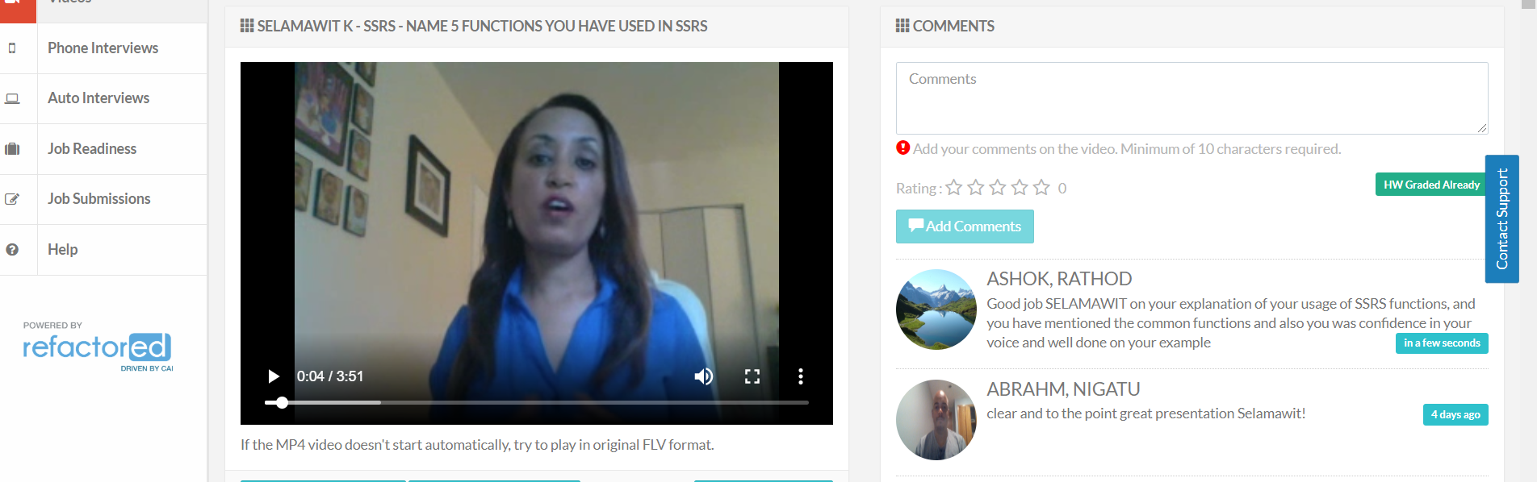

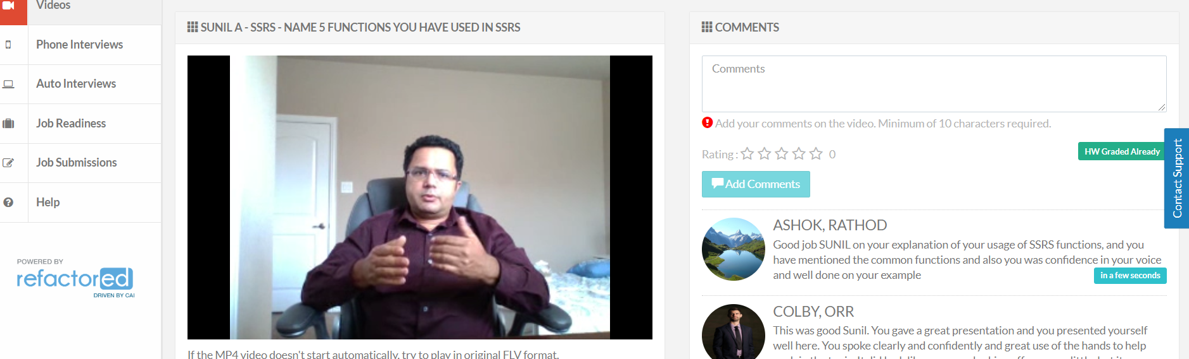

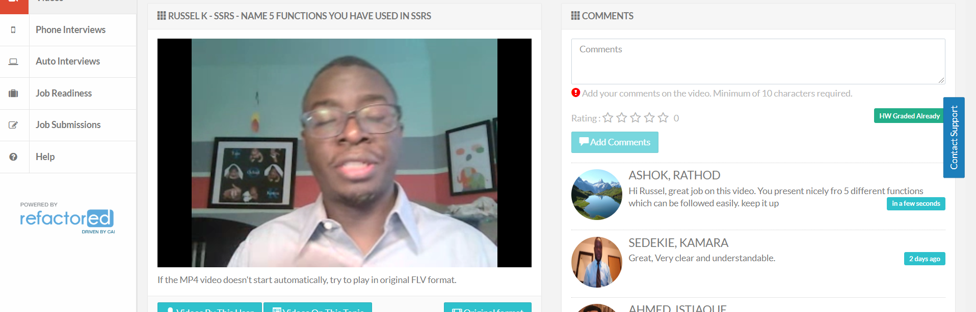

* If you do not have a business analyst on your team, how do you get the requirements

